



NAME: DATE:

CURSILLO DE INGRESO-2025

NAME:

DATE:

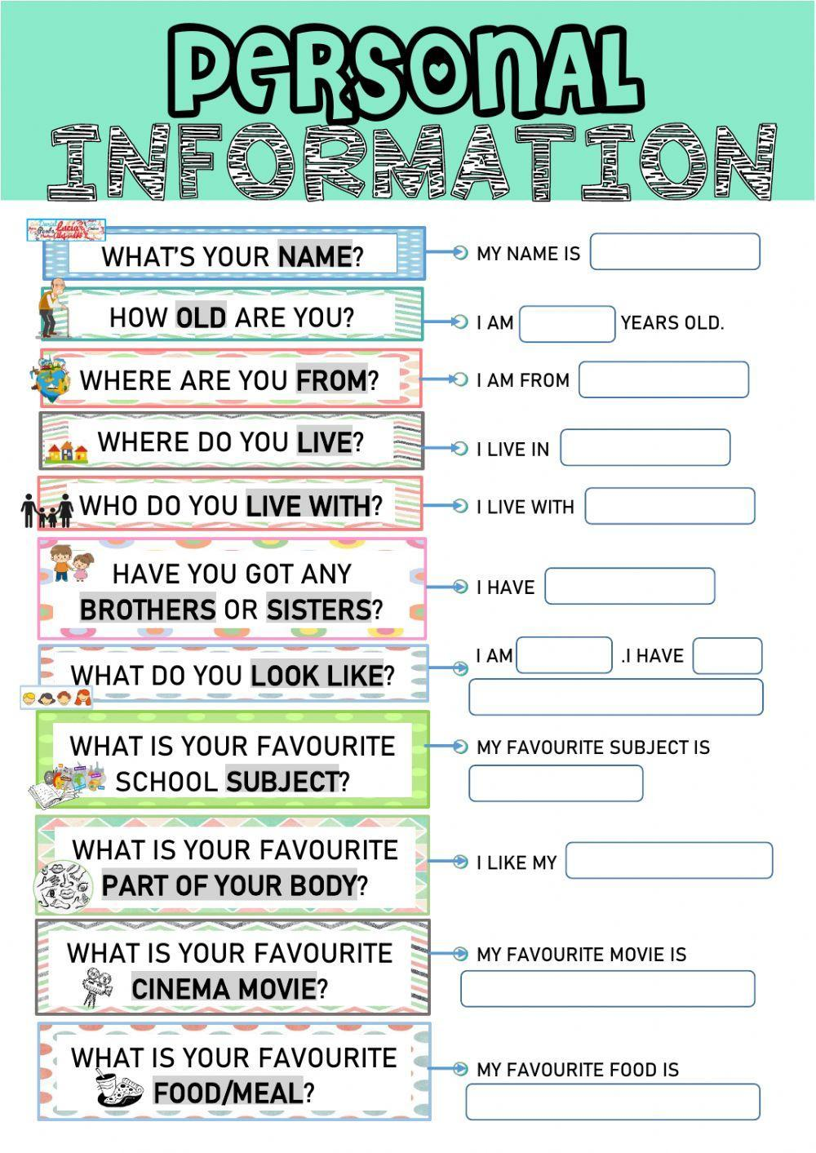

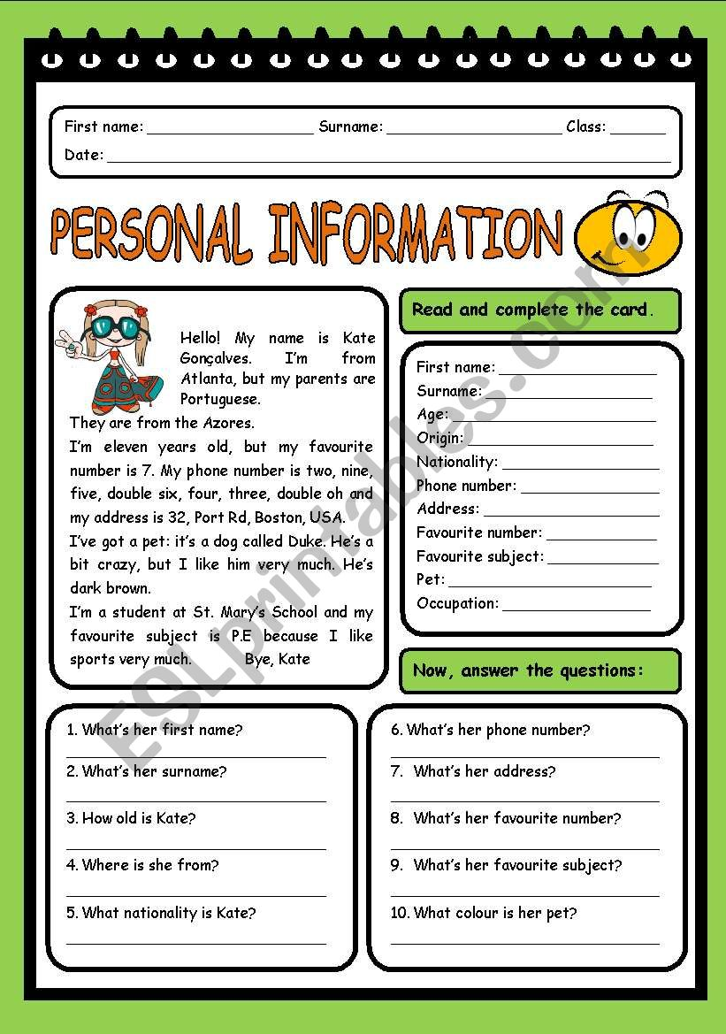

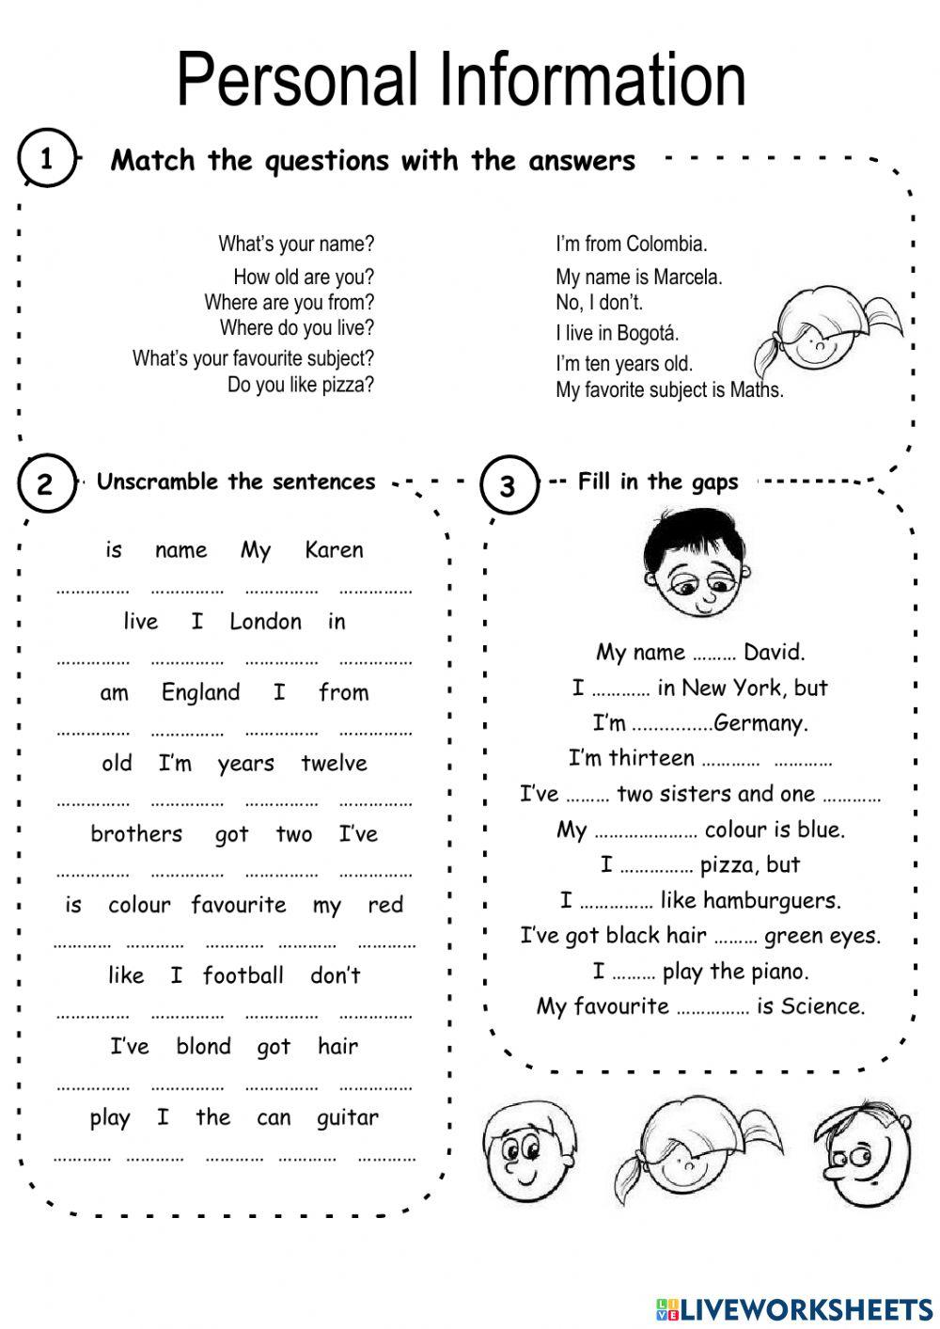

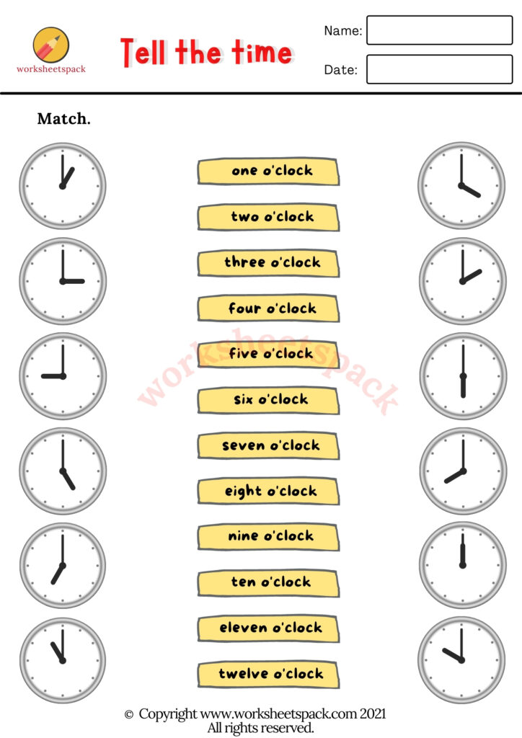

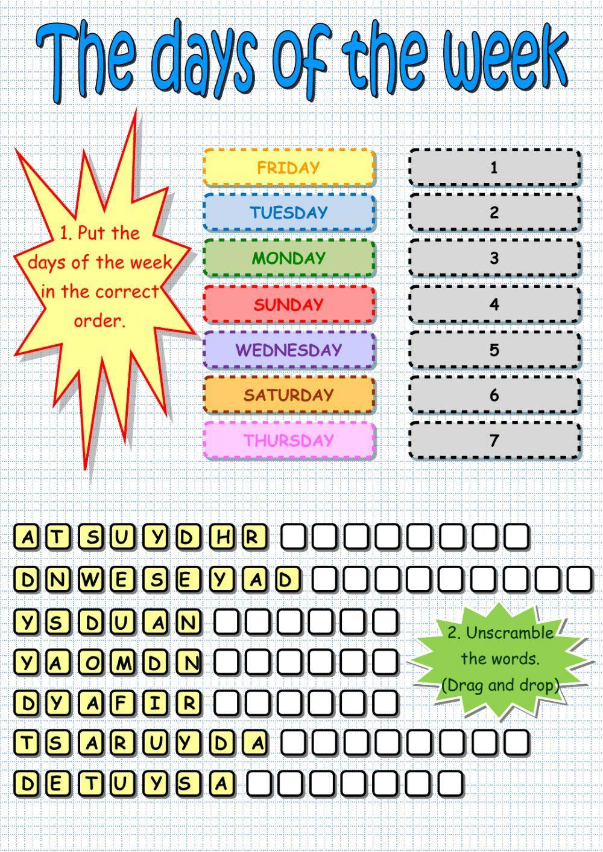

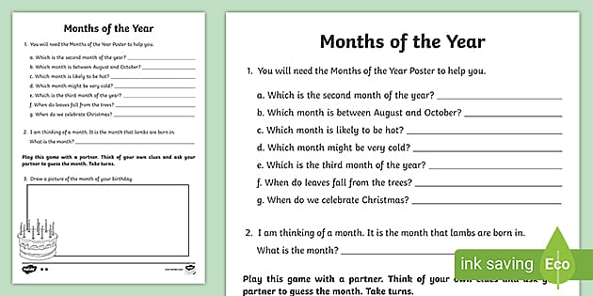

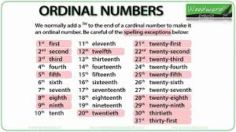

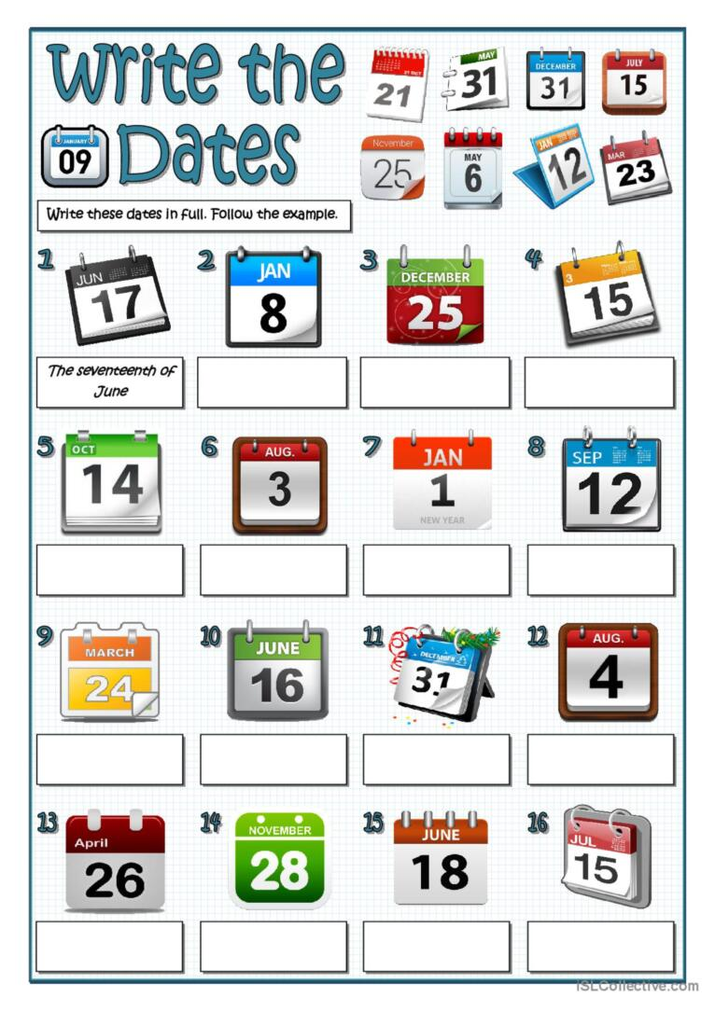

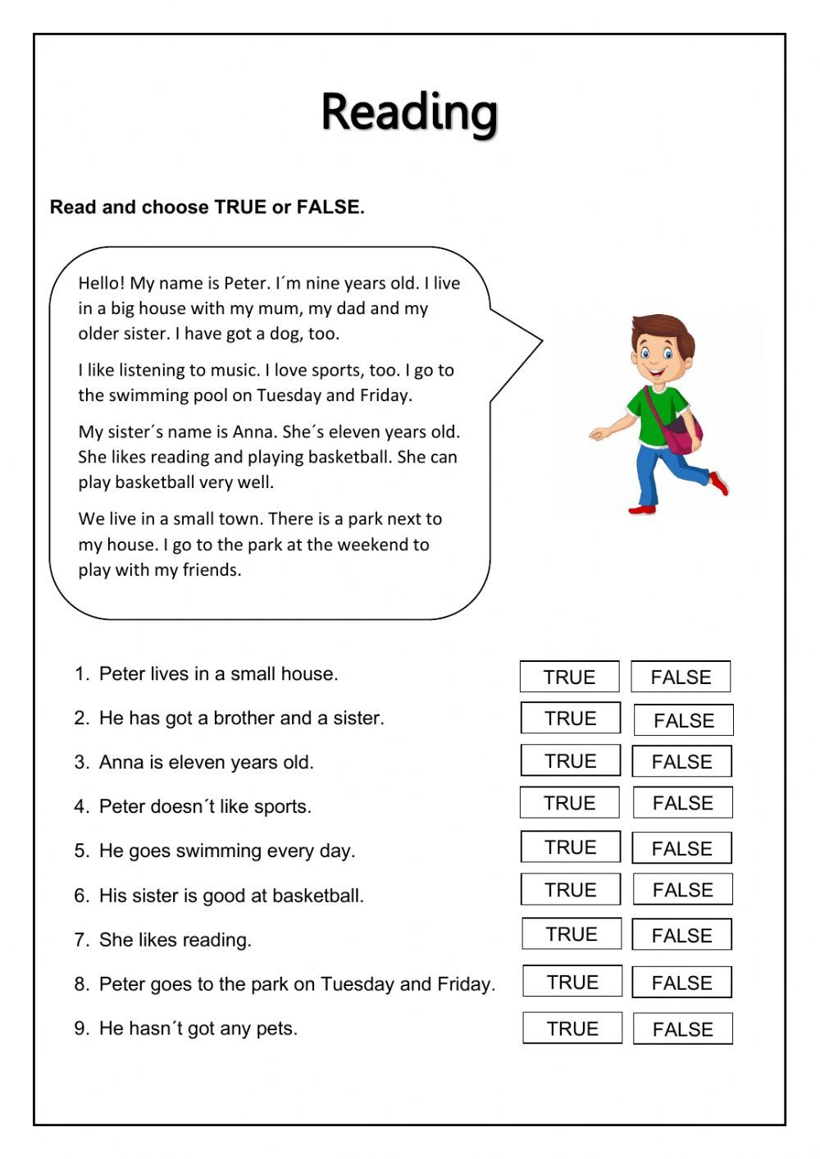

*WRITE A PARAGRAPH ABOUT YOURSELF, USE THE TEXT ABOUT PETER TO HELP YOU.

*WRITE ABOUT 80 WORDS.

*WRITE ABOUT NAME, AGE, CITY, FAMILY, SCHOOL…

________________________________________________________________________________________________________________________________________________________________________________________________________________________________________________________________________________________________________________________________________________________________________________________________________________________________________________________________________________________________________________________________________________________________________________________________________________________________________________________________________________________________________________________________________________________________________________________________________________________________________________________________________________________________________________

*LISTEN AND ANSWER THE QUESTIONS.

