**HOMEWORK: 2do A**

**10th October**

1. 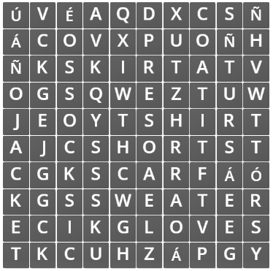Search word. Find: **GLOVES, SWEATER, SHORT, SKIRT, SCARF, COAT, T-SHIRT, JACKET, SOCKS.**
2. 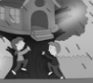Match the sentences with the pictures.
3. I’m wearing…
4. They’re climbing…

**A**

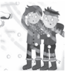

1. They are playing in the…

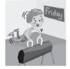

1. She’s visiting her…
2. He’s playing…

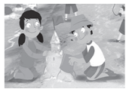

1. I’m doing…



1. She’s listening to…