

**MY ENGLISH HOMEWORK: 18/10 – 1° GRADE - SIMPLE**

**Miss Virginia Grillo**

*REVISION:*

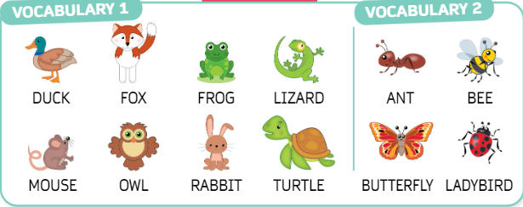

1. LOOK AT THE PICTURES AND WRITE THE WORDS.
2. WHAT ARE THEY?



   